Book Trading Platform

Software Requirements Specification

Version 0.3

13.04.2016

TeamAPO

Revision History

Date | Description | Author | Comments
13.04.2016 | 0.1 | Nikolay | Initial draft
20.04.2016 | 0.2 | M Mlechenkov | Prototype of DB
23.04.2016 | 0.3 | M Mlechenkov | Final prototype of Site

Document Approval

The following Software Requirements Specification has been accepted and approved by the following:
Signature | Printed Name | Title | Date
 | <Your Name>

Table of Contents

Revision History ii
Document Approval ii
1. Introduction 1
1.1 Purpose 1
1.2 Scope 1
1.3 Document Conventions 1
1.4 Definitions, Acronyms, and Abbreviations 1
1.5 References 2
1.6 Overview 2
2. General Description 2
2.1 Product Perspective 2
2.2 Product Functions 2
2.3 User Characteristics 2
2.4 General Constraints 2
2.5 Assumptions and Dependencies 2
3. Specific Requirements 3
3.1 External Interface Requirements 3
3.1.1 User Interfaces 3
3.1.2 Hardware Interfaces 3
3.1.3 Software Interfaces 3
3.1.4 Communications Interfaces 3
3.2 Functional Requirements 3
3.3 Use Cases 4
3.3.1 Use Case #1 4
3.3.2 Use Case #2 4
3.4 Non-Functional Requirements 4
3.4.1 Performance 4
3.4.2 Reliability 4
3.4.4 Security 4
3.5 Logical Database Requirements 4
3.6 Other Requirements 4
4. Change Management Process 5
A. Appendices 5
• Appendix 1 5
• Appendix 2 5

Introduction

The Software Requirements Specification is designed to document and describe the
agreement between the customer and the developer regarding the specification of the
software product requested. Its primary purpose is to provide a clear and descriptive
“statement of user requirements” that can be used as a reference in further
development of the software system. This document is broken into a number of sections
used to logically separate the software requirements into easily referenced parts.
This Software Requirements Specification aims to describe the Functionality, External
Interfaces, Attributes and Design Constraints imposed on Implementation of the
software system described throughout the rest of the document. Throughout the
description of the software system, the language and terminology used should
unambiguous and consistent throughout the document.

Purpose
Defining and describing the functions and specifications of the Book Trading Platform of the SoftUni project Team APO is the primary goal of this Software Requirements Specification (SRS). This Software Requirements Specification illustrates, in clear terms, the system’s primary
uses and required functionality as specified by the customer. It is valuable for all teams included in the development cycle.

Scope
The scope of this document is the functionality of the Book Trading Platform. Main goal of the platform is to effectively allow selling of books to different audiences. Platform should allow for online purchase and should allow account differentiation. This system is designed to “provide automation support” for the process of placing books for sale on the Internet and facilitating the actual sale. This system is largely cross-platform and is available to anyone The system will allow any user to create an account to become a customer. The system will allow customers to browse, search, select, and add books to a shopping cart. Then, provided they have books in their shopping cart, check out books in shopping cart and decrement the stock that the inventory the system maintains. The platform also allows an administrator to manage the inventory with full create, retrieve, update and delete functionality with regards to books in the system. It will also allow, on an inventory wide basis, customers and managers to interact with a promotion system that handles percentage-off promotions that can be applied to member’s orders.

Document Conventions
- Bold text is meant to be more important and thus emphasized
- Italics text is meant to be a quote from another section of the document or external source
- Underlined text is mean to be hyperlink to internal or external information

Definitions, Acronyms, and Abbreviations
SRS – Software Requirements Specification
QA – Quality Assurance team
DEV – Developers’ team
BA – Business Analysis team

References

Overview
This Software Requirements Specification document is divided in to multiple
subsections. The first section includes explanations of the Purpose, Scope and
Organization of the document. The first section also handles the description of projectspecific
words, acronyms and abbreviations that will be used in the document. The
second section of the document is separated into the following five different sections,
each detailing specific details of system uses and their corresponding actions: Product
Perspective, Product Functions, User Characteristics, Constraints, Assumptions and
Dependencies. The third section is an enumerated listing of all of the requirements described for this system. It also encompasses all of the Use-case, Sequence, State and Class diagrams that model the system. The non-fictional requirements and the logical database requirements are listed too .In the fourth section is described the change managing process.

General Description
This section includes details about what is and is not expected of the Book Trading Platform in addition to which cases are intentionally unsupported and assumptions that will be used in the creation of the Book Trading Platform.

Product Perspective
The Book Trading Platform is an online bookstore website which supports a number of functions for both the consumer and store's management. The website must be available to anyone working correctly in both Internet Explorer and Mozilla Firefox. As stated by the customer, there are no hardware or software requirements beyond these including, but not limited to, memory or specific software packages that need to be utilized nor software packages that need not be utilized.
My Book store is an online web application where the customer can purchase books online. Through a web browser the customers can search for a book by its title or author, later can add to the shopping cart and finally purchase using credit card transaction. The user can login using his account details or new customers can set up an account very quickly. They should give the details of their name, contact number and shipping address. The user can also give feedback to a book by giving ratings on a score of five. The books are divided into many categories based on subject Like Software, Database, English, Architecture e

Product Functions
This project has the following functionalities:

1) A Home page with product catalog
This is the page where the user will be navigated after a successful login. It will display all the book categories and will have a search keyword option to search for the required book. It also includes some special sections like recommended titles, weekly special books.

2) Search
A search by keyword option is provided to the user using a textbox .The keyword to be entered should be the book title.

3) Advanced Search
Advanced search helps the user to search for a book based on Title, Author, Category and price range. All the books which match the particular search criteria and their total count will be displayed .From here the user can select a book and add to the shopping cart.

4) Book Description
If the user would like to know details about a book he can click on the title from where he will be directed to a Book description page. It includes the notes on the book content and also a link to Amazon.com to get the book review.

5) User Voting
The user can give rating to a book based on his interest. He can rate it by giving a score of five as Excellent, four for very good, three for good, two for regular and one for deficient. The final rating of a book will depend on all the individual user rating.

6) Shopping Cart
The user can manage a shopping cart which will include all the books he selected. The user can edit, delete and update his shopping cart. A final shopping cart summary is displayed which includes all the items the user selected and the final total cost.

7) Managing user accounts
Each user should have an account to access all the functionalities of website. User can login using login page and logout using the logout page. All the user sessions will be saved in the database.

8) Administration
The Administrator will be provided with special functionalities like
• Add or delete a book category
• Add or delete a member
• Manage member orders.
• Add or delete a Credit Card type.

User Characteristics
The typical user is simply anyone that has access to the Internet and a web. It is assumed that the user is familiar enough with a computer to operate the browser, keyboard and mouse and is capable of browsing to, from and within simple website.

General Constraints
In order to create good software, design constraints and other contingencies need to be addressed. In this section we will enumerate any and all considerations that must be made when creating this project.
- Must be coded efficiently enough to run well on provided server Hardware
- Client side code and/or web pages must be able to run efficiently on low end hardware
- The database will be created and maintained in a way that makes it of reasonable and manageable size.

Assumptions and Dependencies
Client:
We have assumed that the computer systems used by the future members of the book trading platform is in proper working condition and that the user is capable of operating these system's basic functions including but not limited to being able to power on the system, login and open and navigate the browser to the address of this My Book Store website.

Provider:
We have assumed that the platform will be running on a properly working web server and database system with an Internet connection that allows this system to perform all communications with clients.

Specific Requirements /software, hardware, others/
- Mouse
- Keyboard
- Monitor
- Cables
- ups - http://most.bg/ups-ustroystva/aeg-protect-b-1500-lcd.html
- server - http://most.bg/intel-server-system-sr2625urlx.html
- SSD – minimum 500GB/1TB

- Operation System (Windows Server 2016)
- SQL Server (2014)

SQL Server Management Studio
- Microsoft Internet Information Services (IIS) Manager version 8.0 or 8.5, .NET framework 4.5

Functional Requirements
All the requirements are specified by various use cases. User and Administrator are the two main actors included in the Book Trading Platform.Fig.1 shows the use case diagram for this website.

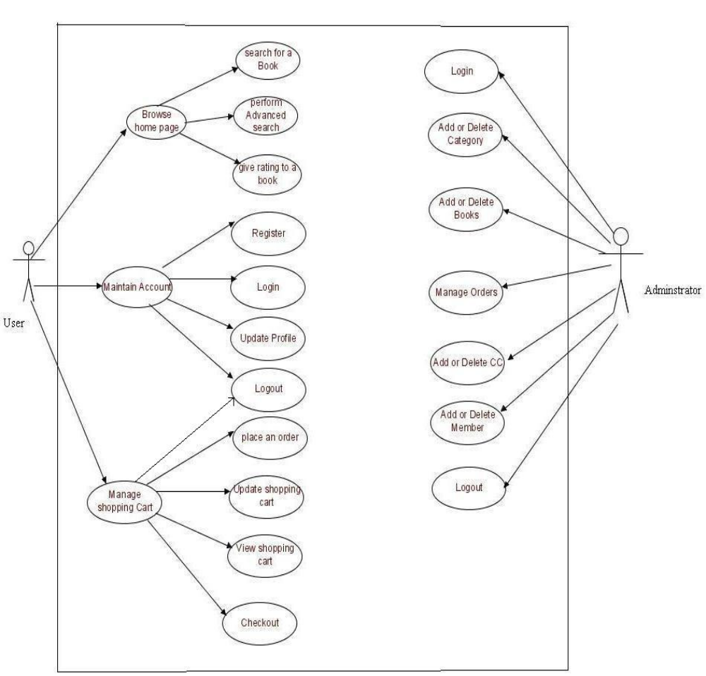
Fig.1 Use Case Diagram

Use Cases

Use Case #1

Use Case #2
…
…

Non-Functional Requirements

Performance
Order Volumes
Order Statistics | Year 1 | Year 2 | Year 3 | Year 4 | Year 5 | Notes
Orders | 5,000 | 10,000 | 15,000 | 20,000 | 25,000
Number of items | 15,000 | 25,000 | 35,000 | 45,000 | 55,000
Average basket size (no items) | 2 | 2 | 2 | 2 | 2
Average orders / day | 14 | 27 | 41 | 55 | 68
Database Order Sizing
# Orders Stored | 5,000 | 15,000 | 25,000 | 35,000 | 45,000 | Assumes 2 year retention
Total Orders Storage Required (KB) | 7,500 | 22,500 | 37,500 | 52,500 | 67500
Total Orders Storage Required (GB) | 0.00087 | 0.0026 | 0.0044 | 0.0061 | 0.0078

Reliability

The system must have less than 1hr downtime per three months

Security
- Admin users must authenticate with userId and password.
- 5 or more failed attempts to login → account lockout. Accounts should unlock after 60 minutes of no attempts.
- Client-side and Server-side Validation.
- The system must control access to certain areas and features of a site through use of a basic Access Control Level mechanism:
  - Administrator – Level 2 allows access to all administration functions.
  - Members – Level 1 allows the registered user to login to the Front-end interface. Members can't contribute content, but this may allow them access to other areas, like a Product List Page (PLP) and Product Detail Page (PDP).
- All system data must be backed up every 24 hours and the backup copies stored in a secure location which is not in the same building as the system.
- All external communications between the system’s data server and clients must be encrypted..

Logical Database Requirements
Web site will use a database to store information. The requirement is to use a relational database. Provide a prototype and the relations between tables.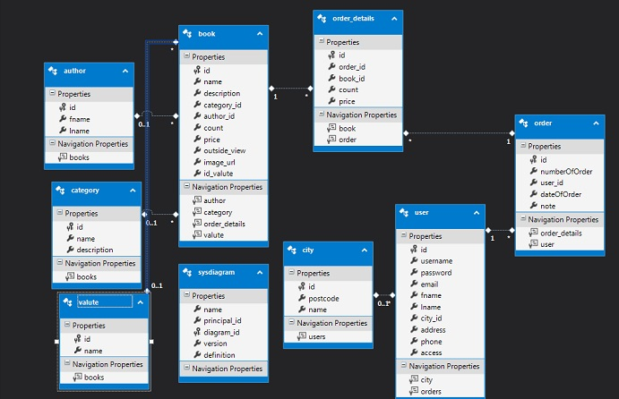

Other Requirements
To use the project (website) are needed library knowledge of administrative users in a Project.

Change Management Process
Requirement change management process defines the set of activities that need to be performed when there are some new requirements or changes to existing requirements (we will call both of these as changes in the requirements). Requirement changes can occur at any point during the project execution stage. The basic goal of requirement change management process is to control requirement changes and minimize the impact of changes on the project.
This involves understanding the full impact of a requirement change request, as well as the cumulative impact of changes, on the project. It also requires making the customer fully aware of the impact of the changes on the project so that changes in the negotiated terms can be done amicably. The requirements change management process, in a sense, tries to ensure that a project succeeds despite requirement changes.

The Process

There are two aspects to requirements change management – agreement with the customer about how the changes will be dealt with, and the process of actually making the changes. The overall approach for handling changes has to be agreed by the customer, and is frequently a part of the proposal as well as the project management plan. Generally, this specifies how the change requests will be made, when formal approvals are needed, building a buffer in the estimates for handling changes etc. In the context of the overall approach, when a request for a requirement change comes in, the requirements change management process has to be executed. The project leader is primarily responsible for executing the process to incorporate the change in the project. However, the customer, the business manager to whom the project leader reports, and the development team also participate in this process. The entry criterion for this process is that a change request has been received, and the inputs are the change request and the work products that have already been produced in the project. The main outputs are the impact analysis report for the change request, revised project plan, and changed work products, and the exit criterion is that the change has been incorporated. The major steps in the process are:
Log changes
Perform impact analysis on the work products
Estimate effort needed for this change requests
Re-estimate delivery schedule
Perform cumulative cost impact analysis
Review impact with senior management, if thresholds are exceeded
Obtain customer sign off
Rework work products
A change request log is maintained to keep track of the change requests. Each entry in the log contains a change request number, a brief description of the change, the impact of the change, the status of the change request and key dates. The effect of a change request is assessed by performing impact analysis. Impact analysis involves identifying work products that need to be changed, and evaluating the quantum of change to each; reassessing the project’s risks by revisiting the risk management plan; and evaluating the overall impact of the changes on the effort and schedule estimates. The outcome of the analysis is reviewed and approved by the project leader and the customer. The change request itself is incorporated in the requirement specification document, usually as appendices. Sometimes the relevant portions of the document may also be modified to reflect the changes. Monitoring of approved change requests and ensuring proper implementation of change request is handled by the configuration management process, which is discussed in a later chapter.

Appendices

Appendix 1 – Basic Bug Workflow v 1.0 – JIRA http://goo.gl/E3wMMj

Appendix 2

